MathWorks^{e} Training Services

Course Completion Certificate
Ikeo Jesca
has successfully completed 100% of the self-paced training course

MAT LAB Onramp
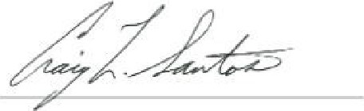
DIRECTOR, TRAINING SERVICES

18 September 2025

